**SUTD 50.001 Introduction to Information Systems and Programming**

**Problem Set 2A**

|  |
| --- |
| **Note:**   * **For all questions, please access the vocareum link found at eDimension for the starter code and to submit.** * **The Vocareum link is for submission only. Please work on the problems in Android studio, and this includes writing code for the test cases.** * **To prevent hard-coding, test cases used in Vocareum *may* be different from those provided here and will not be given to you.** |

1. [10 points] Title: Comparable interface

Given the following Octagon class:

**public class** Octagon {  
 **private double side**;  
 **public** Octagon(**double** side){  
 **this**.**side** = side;  
 }  
 **public double** getSide() {  
 **return side**;  
 }  
}

Assume that all eight sides of the Octagon are of equal size.

Modify Octagon class to implement the Comparable<Octagon> interface to allow sorting of Octagon objects based on their perimeters.

Test code:

**public class** Test {  
 **public static void** main(String[] args) {  
 ArrayList<Octagon> l = **new** ArrayList<Octagon>();  
 l.add(**new** Octagon(2));  
 l.add(**new** Octagon(3));  
 l.add(**new** Octagon(1));  
 Collections.*sort*(l);  
 **for** (Octagon o:l)  
 System.***out***.println(o.getSide());  
 }  
}

Results:

1.0

2.0

3.0

2. [10 points] Title: Comparator interface

Given the following Octagon class, same as previous question:

**public class** Octagon {  
 **private double side**;  
 **public** Octagon(**double** side){  
 **this**.**side** = side;  
 }  
 **public double** getSide() {  
 **return side**;  
 }  
}

Assume that all eight sides of the Octagon are of equal size.

Implement a OctagonComparator class to implement the Comparator<Octagon> interface to allow sorting of Octagon objects based on their perimeters.

Test code:

**public class** TestOctagonComparator {  
 **public static void** main(String[] args) {  
 ArrayList<Octagon> l = **new** ArrayList<Octagon>();  
 l.add(**new** Octagon(2));  
 l.add(**new** Octagon(3));  
 l.add(**new** Octagon(1));  
 Collections.*sort*(l, **new** OctagonComparator());  
 **for** (Octagon o:l)  
 System.***out***.println(o.getSide());  
 }  
}

Results:

1.0

2.0

3.0

3. [Total: 20 points]

Use the Observer design pattern to develop an air pollution alert system that sends the air pollution index to all the subscribed users if the air pollution index is more than 100.

The starting code has been provided. Modify AirPollutionAlert class to implement interface Subject. You only need to modify AirPollutionAlert class according to the Observer design pattern. Do not modify Subscriber class.

If your implementation of Observer Design Pattern is correct, you should see following results.

Example test code:

public class Test{

public static void main(String[] args) {

AirPollutionAlert singaporeAlert = new AirPollutionAlert();

Subscriber man = new Subscriber("man",singaporeAlert);

Subscriber simon = new Subscriber("simon", singaporeAlert);

singaporeAlert.setAirPollutionIndex(200);

singaporeAlert.setAirPollutionIndex(50);

singaporeAlert.setAirPollutionIndex(120);

singaporeAlert.unregister(man);

singaporeAlert.setAirPollutionIndex(300);

}

}

Output:

man received notification: 200.0

simon received notification: 200.0

man received notification: 120.0

simon received notification: 120.0

simon received notification: 300.0

4. [Total: 20 points]

Develop the software using inheritance and interfaces as shown in the following figure. Note that an arrow from P to Q means that P is a subclass/sub-interface of Q, or P implements Q.

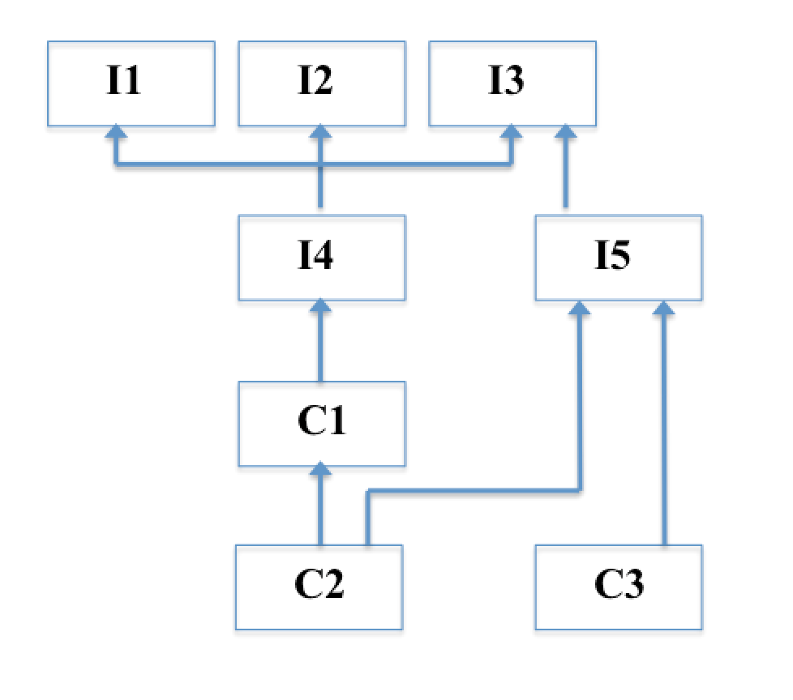

Interface I1 contains a method int p1();

Interface I2 contains a method int p2();

Interface I3 contains a method int p3();

Interface I4 contains a method int p4(); Note that I4 also inherits accessible programming constructs from I1, I2, I3, as shown in the figure.

Interface I5 contains a method int p5();

Class C1 contains only an abstract method int q1(); Note that C1 also implements I4 as shown in the figure.

Class C2 is a concrete class and provides all the needed implementations of methods. All the implementations simply return 0.

Class C3 is a concrete class and provides all the needed implementations of methods. All the implementations simply return 0.

5. [20 points] Title: Palindrome

https://en.wikipedia.org/wiki/Palindrome

Write a recursive method for finding palindromes. For each string your program should produce an answer of the form “<the input string> is a palindrome.”, or “<the input string> is not a palindrome.”. Assume that the string does not contain whitespace characters.

Example outputs:

abba is a palindrome.

abdcba is not a palindrome.

ZZaZZ is a palindrome.

124321 is a not palindrome.

Note: No credit will be given for non-recursive code.

6. [Total: 30 points]

Permutation: Write a **recursive** method ‘permute()’ that computes all possible orderings of the characters in a string, i.e., all permutations that use all the characters from the original string.

For example, given the string ‘hat’, you code should produce the strings:

‘tha’, ’aht’, ’tah’, ’ath’, ’hta’, ’hat’

You can assume that the characters are distinctive and there is no repeated character.

No credit will be given for non-recursive code.

The list of permutations can be in any order.

**public class** Permutation {  
 **private final** String **in**;  
 **private** ArrayList<String> **a** = **new** ArrayList<String>();  
 *// additional attribute if needed* Permutation(**final** String str){  
 **in** = str;  
 *// additional initialization if needed* }  
  
 **public void** permute(){  
 *// produce the permuted sequences of 'in' and store in 'a', recursively* }  
  
 **public** ArrayList<String> getA(){  
 **return a**;  
 }  
}

**public class** TestPermutation {  
 **public static void** main(String[] args) {  
 ArrayList<String> v;  
  
 Permutation p = **new** Permutation(**"hat"**);  
 p.permute();  
 v = p.getA();  
 System.***out***.println(v);  
}  
}

Output:

[hat, hta, aht, ath, tha, tah]

7. [30 points] Robot

A robot starts from the upper left corner of a grid (0,0) and attempts to move to spot (r,c). At every step, the robot can only move in two directions: right and down. Some spots are “blocked”, such that the robot cannot step on these positions. Design a static method **getPath** (inside a new class **GetPath**) to find a path for the robot to move from the top left (0,0) to a spot (r,c), **recursively**. The method returns **true** and the path, if such a path can be found, or **false** if such a path cannot be found.

The grid is represented as an integer 2-d array: a ‘0’ indicates the spot is non-blocked, a ‘1’ indicates the spot is blocked. The starting point (0,0) is always non-blocked.

In the method: public static boolean getPath (int r, int c, ArrayList<Point> path, final int [][] grid)

The arguments **r, c** specify the destination spot. The method returns **true** if a path can be found, returned in path. The grid is passed in as the last input argument **grid**.

No credit will be given for non-recursive code.

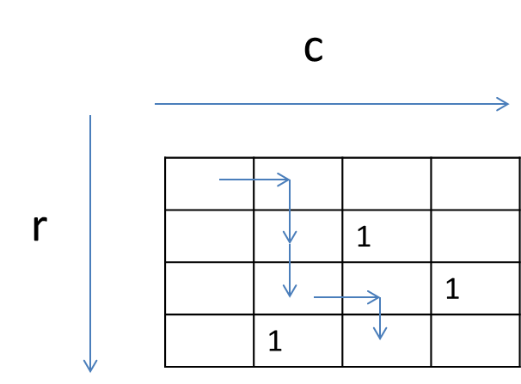

Code:

**class** Point {  
 **int x**;  
 **int y**;  
  
 Point (**int** x, **int** y) {  
 **this**.**x**=x;  
 **this**.**y**=y;  
 }  
  
 **public** String toString() {  
 **return "("** + **x** + **","** + **y** + **")"**;  
 }  
  
}

**public class** TestRobot {  
  
 **public static void** main(String[] args) {  
  
 **final int** [][] grid0 = {  
 {0,0,0,0},  
 {0,0,1,0},  
 {0,0,0,1},  
 {0,1,0,0}  
 };  
  
  
 ArrayList<Point> path = **new** ArrayList<>();  
  
 **boolean** success = GetPath.*getPath*(3,2,path, grid0);  
  
 System.***out***.println(success);  
 **if** (success)  
 System.***out***.println(path);  
 path.clear();  
  
  
 **final int** [][] grid = {  
 {0,0,0,0},  
 {0,0,1,0},  
 {0,1,0,1},  
 {0,1,0,0}  
 };  
  
 success = GetPath.*getPath*(3,2,path, grid);  
  
 System.***out***.println(success);  
 **if** (success)  
 System.***out***.println(path);  
 path.clear();  
  
}  
  
  
}

Output:

true  
[(0,0), (0,1), (1,1), (2,1), (2,2), (3,2)]  
false

(Note that your output path may not be exactly the same but you should validate that it is a valid path)

8. [10 points] (ArrayIndexOutOfBoundsException) Write a method:

public static String tstException(int idx, String[] y)

Given the index of the array, the method returns the corresponding element value. If the specified index is out of bounds, the method returns the message “Out of Bounds”.

Note: Use try-catch to implement the method.

**public class** TestException {  
 **public static void** main(String[] args) {  
 String[] in = {**"hello"**, **"good night"**, **"good morning"**};  
  
 String ret = *tstException*(2, in);  
  
 System.***out***.println(ret);  
  
 ret = *tstException*(-1, in);  
  
 System.***out***.println(ret);  
 }  
  
  
 **public static** String tstException(**int** idx, String[] y) {  
 // to be implemented  
   
 }  
}

**Output:**

good morning

Out of Bounds